Udemy CKA Questions:

Question No: 1
Create a Horizontal Pod Scaler (HPA) named apache-server in the auto-scale namespace. This HPA must target existing deployment called apache-server in the auto-scale namespace.
Set the HPA to aim for 50% CPU usage per pod. Configure it to have at least 1 pod and at max 4 pod.
Also set the downscale stabilization window to 30 seconds.
Ans.
controlplane:~$ k create ns autoscale
controlplane:~$ k create deployment apache-server --image nginx --replicas=1 -n autoscale
controlplane:~$ kubectl autoscale deployment apache-server --namespace autoscale --cpu=50% --min=1 --max=4
controlplane:~$ k get hpa -n autoscale
NAME REFERENCE TARGETS MINPODS MAXPODS REPLICAS AGE
apache-server Deployment/apache-server cpu: <unknown>/50% 1 4 1 3m10s
apiVersion: autoscaling/v2
kind: HorizontalPodAutoscaler
metadata:
name: apache-server
namespace: autoscale
spec:
scaleTargetRef:
apiVersion: apps/v1
kind: Deployment
name: apache-server
minReplicas: 1
maxReplicas: 4
metrics:
- type: Resource
resource:
name: cpu
target:
type: Utilization
averageUtilization: 50
behavior:
scaleDown:
stabilizationWindowSeconds: 30

Question No: 2 Weightage: 10%
Reconfigure the existing deployment front-end in namespace spline-reticulator to expose port 80/tcp of the existing container nginx.
• Create a new service named front-end-svc exposing the container port 80/tcp.
Configure the new service to also expose the individual pod via a NodePort.
Ans.
controlplane:~$ k create ns spline-reticulator
namespace/spline-reticulator created
controlplane:~$ k create deployment front-end --image nginx --namespace spline-reticulator
deployment.apps/front-end created
controlplane:~$ k get deploy -n spline-reticulator
NAME READY UP-TO-DATE AVAILABLE AGE
front-end 1/1 1 1 28s
controlplane:~$ kubectl get deployment front-end -n spline-reticulator -o yaml > front-end-deployment.yaml
controlplane:~$ vi front-end-deployment.yaml
controlplane:~$ k apply -f front-end-deployment.yaml
Warning: resource deployments/front-end is missing the kubectl.kubernetes.io/last-applied-configuration annotation which is required by kubectl apply. kubectl apply should only be used on resources created declaratively by either kubectl create --save-config or kubectl apply. The missing annotation will be patched automatically. deployment.apps/front-end configured
ports:
- containerPort: 80
protocol: TCP
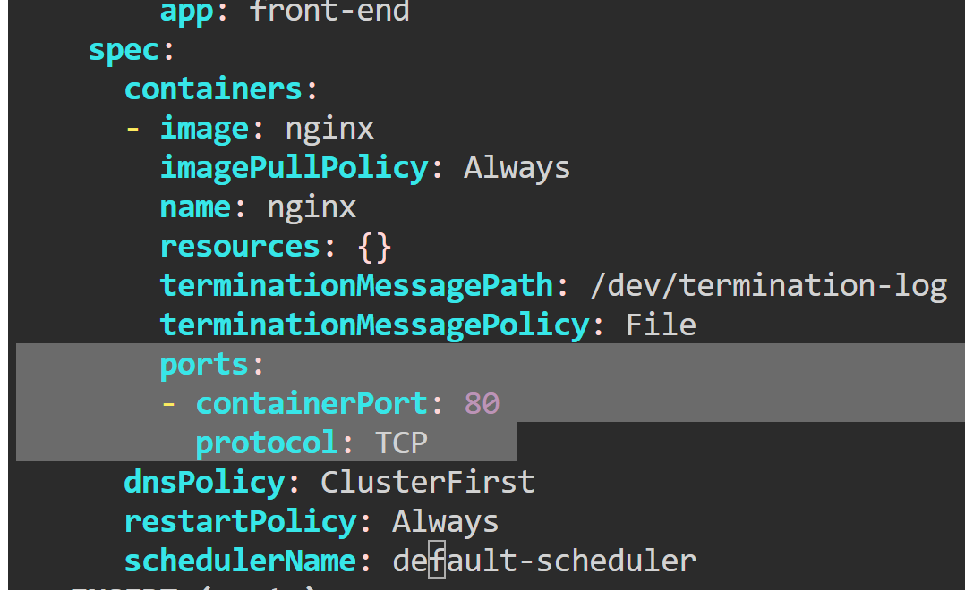
controlplane:~$ k describe deployment front-end -n spline-reticulator (check port)
controlplane:~$ k set container-port deployment/front-end nginx=80 -n spline-reticulator
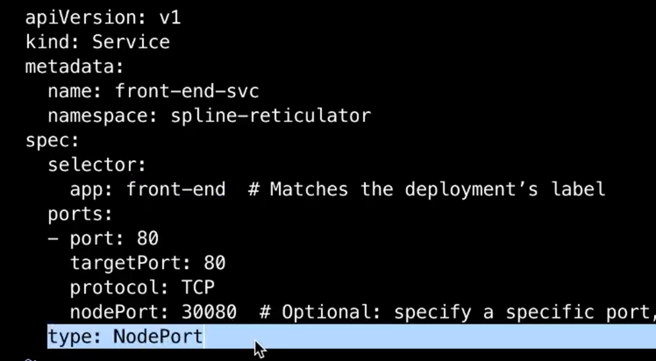

Question No: 3 Weightage: 15%
Update the existing deployment synergy-leverager, adding a co- located container named sidecar using the busybox:stable image to the existing pod.
• The new co-located container has to run the following command: /bin/sh -c "tail -n+1 -f /var/log/synergy-leverager.log" Use a volume mounted at /var/log to make the log file synergy- leverager.log available to the co-located container.
Ans.
controlplane:~$ vi synergy-leverager-deploy.yaml
apiVersion: apps/v1
kind: Deployment
metadata:
name: synergy-leverager
labels:
app: synergy-leverager
spec:
replicas: 1
selector:
matchLabels:
app: synergy-leverager
template:
metadata:
labels:
app: synergy-leverager
spec:
containers:
- name: app
image: nginx:latest
volumeMounts:
- name: log-volume
mountPath: /var/log
- name: sidecar
image: busybox:stable
command: ["/bin/sh", "-c", "tail -n+1 -f /var/log/synergy-leverager.log"]
volumeMounts:
- name: log-volume
mountPath: /var/log
volumes:
- name: log-volume
emptyDir: {}
Question No: 4 Weightage: 11%
Perform the following tasks:
Create a new PriorityClass named high-priority for user workloads with a value that is one less than the highest existing user-defined priority class value.
Patch the existing Deployment busybox-logger running in the priority namespace to use the high-priority priority class. Ensure that the busybox-logger Deployment rolls out successfully with the new priority class set.
Note - It is expected that pods from other Deployments running in the priority namespaces are evicted.
Ans.
controlplane:~$ k create ns priority
controlplane:~$ k create priorityclass existing-priority --value=1000 --description="Existing user priority class"
controlplane:~$ k create deployment busybox-logger --image=busybox --namespace=priority --replicas=2 -- sh -c "while true; do echo 'Logging...'; sleep 5; done"
deployment.apps/busybox-logger created
controlplane:~$ k create priorityclass high-priority --value=999 --description="High priority class for user workloads"
priorityclass.scheduling.k8s.io/high-priority created
controlplane:~$ kubectl patch deployment busybox-logger -n priority --patch '{"spec": {"template": {"spec": {"priorityClassName": "high-priority"}}}}'
deployment.apps/busybox-logger patched

Question No: 5 Weightage: 8%
First, create a new StorageClass named local-path for an existing provisioner named rancher.io/local-path. Set the volume binding mode to WaitForFirstConsumer
Note - Not setting the volume binding mode or setting it to anything other than WaitForFirstConsumer may result in reduced score. Next, Configure the StorageClass local-path as the default StorageClass.
Note - Do not modify any existing Deployments or Persistent VolulmeClaims. Failure to do so may result in a reduced score.
Ans. controlplane:~$ k apply -f storageclass.yaml
storageclass.storage.k8s.io/local-path configured
controlplane:~$ k get storageclasses.storage.k8s.io

NAME PROVISIONER RECLAIMPOLICY VOLUMEBINDINGMODE ALLOWVOLUMEEXPANSION AGE
local-path (default) rancher.io/local-path Delete WaitForFirstConsumer false 12d
controlplane:~$ k patch storageclass local-path -p '{"metadata": {"annotations":{"storageclass.kubernetes.io/is-default-class":"true"}}}'
storageclass.storage.k8s.io/local-path patched (no change)
https://kubernetes.io/docs/tasks/administer-cluster/change-default-storage-class/
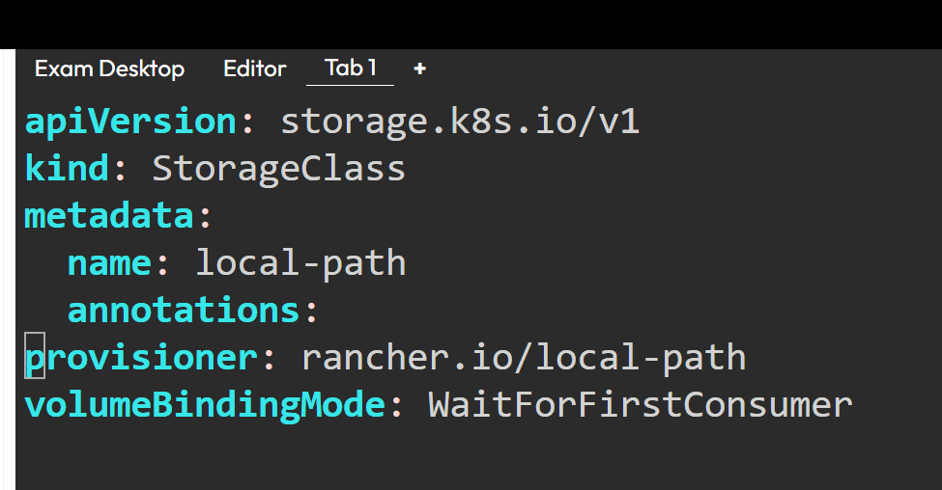
controlplane:~$ k get storageclass local-path -o yaml
Question No: 6 Weightage: 7%
Install ArgoCD in the cluster by performing the following tasks: Add the official Argo CD Helm repository with the name argo.
Generate a template of the ArgoCD Helm Chart version 7.7.3 for the argocd namespace and save it to ~/argo-helm.yaml.
Configure the chart to not install CRDs.
Note - The Argo CD CRDs have already been pre-installed in the cluster.
kubectl apply -k https://github.com/argoproj/argo-cd/manifests/crds\?ref\=stable
controlplane:~$ helm repo add argo https://argoproj.github.io/argo-helm
controlplane:~$ controlplane:~$ helm repo update
Hang tight while we grab the latest from your chart repositories...
...Successfully got an update from the "argo" chart repository
Update Complete. ⎈Happy Helming!⎈
controlplane:~$ helm repo list
NAME URL
argo https://argoproj.github.io/argo-helm
controlplane:~$
helm template argo argo/argo-cd --version 7.7.3 --namespace argocd --set crds.install=false > ~/argo-helm.yaml

Question No: 7 Weightage: 13%
A MariaDB Deployment in the mariadb namespace has been deleted by mistake. Your task is to restore the Deployment ensuring data persistence. Follow the steps:
Create a PersistentVolumeClaim (PVC) named mariadb in the mariadb namespace with the following specifications: Storage 250Mi
Note - You must use the existing retained PersistentVolume (PV). There is only one existing PersistentVolume.Edit the MariaDB Deployment file located at ~/mariadb-deployment.yaml to use the PVC you created in the previous step. Apply the updated Deployment file to the cluster.
controlplane:~$ cat mariadb-pvc.yaml
apiVersion: v1
kind: PersistentVolumeClaim
metadata:
name: mariadb
namespace: mariadb
spec:
accessModes:
- ReadWriteOnce
resources:
requests:
storage: 250Mi
storageClassName: standard
controlplane:~$ cat marida-pv.yaml
apiVersion: v1
kind: PersistentVolume
metadata:
name: mariadb-pv
spec:
capacity:
storage: 300Mi
accessModes:
- ReadWriteOnce
persistentVolumeReclaimPolicy: Retain
storageClassName: standard
hostPath:
path: "/tmp/mariadb-data"
controlplane:~$
#Mariabd Deployment Yaml
apiVersion: apps/v1
kind: Deployment # what to create?
metadata:
name: mariadb
namespace: mariadb
spec: # specification for deployment resource
selector:
matchLabels:
app: mariadb
template: # blueprint for pods
metadata:
labels:
app: mariadb # service will look for this label
spec: # specification for Pods
containers:
- name: mariadb
image: mariadb:latest
ports:
- containerPort: 3306
env:
- name: MARIADB_ROOT_PASSWORD
value: secret
volumeMounts:
- name: mariadb-storage
mountPath: /var/lib/mysql
volumes:
- name: mariadb-storage
persistentVolumeClaim:
claimName: mariadb
Question No: 8 Weightage: 12%
Migrate an existing web application from Ingress to Gateway API. You must maintain HTTPS access.
First, create a Gateway named web-gateway with hostname gateway.web.k8s.local that maintains the existing TLS and listener configuration from the existing ingress resource named web.
Next, create an HTTPRoute named web-route with hostname gateway.web.k8s. local that maintains the existing routing rules from the current Ingress resource named web.
Note - A GatewayClass named nginx is installed in the cluster.

Question No: 9
Weightage: 10%
Install and set up a Container Network Interface (CNI) that meets these requirements: Pick and install one of the CNI options:
The CNI you choose must satisfy following requirement: <native network policy support>
Flannel version 0.26.1
Manifest - https://github.com/flanner-io/flanner/releases/
download/v0.26.1/kube-flanner.yml
Calico version 3.28.2
Manifest - https://raw.githubusercontent.com/projectcalico/
calico/v3.28.2/manifests/tigera-operator.yaml

Question No: 10 Weightage: 9%
You manage a WordPress application. Some pods are not up and running. Adjust all Pod resource requests as follows:
• Divide node resources evenly across all 3 pods.
• Give each Pod a fair share of CPU and memory.
• Add enough overhead to keep the node stable.
• Note - Use exact same requests for both containers and init containers. Scale down the wordpress deployment to 0 replicas while updating the resource requests.
• After updates, confirm:- WordPress keeps 3 replicas.- All Pods are running and ready.

Question No: 11
Complete these tasks to prepare the system for Kubernetes: Set up cri-dockerd:
Weightage: 10%
• Install the Debian package:
• ~/cri-dockerd_0.3.9.3-0.ubuntu-focal_amd64.deb
• Start the cri-dockerd service.
• Enable and start the systemd service for cri-dockerd.
Configure these system parameters:
• Set net.bridge.bridge-nf-call-iptables to 1.
• Set net.ipv6.conf.all.forwarding to 1.
• Set net.ipv4.ip_forward to 1.

Question No: 12 Weightage: 7%
- List all custom crd from cert manager and store it in custom- crd.txt.
- Get the subject field from the cert manager and store it in cert-manager-subject.txt

Ans:
kubectl get crd certificates.cert-manager.io -o jsonpath={.spec.versions[*].schema.openAPIV3Schema.properties.spec.properties.subject}

Question No: 13
Weightage: 10%
There are two deployments. frontend and backend deployment. frontend will be in frontend NS and backend will be in backend NS. Apply the least permissive policy to have interaction between frontend and backend deployment.
Below are the 3 YAML file to apply network policy.
Choose either of them with least permission.
1 YAML - pod selector of all. type is ingress and pod selector with all
2 YAML - pod selector as well as namsespace selector are present
3 YAML - pod selector, NS selector, POD CIDR

Question No: 14
Weightage: 10%
An nginx deployment configured via a ConfigMap containing the Nginx config file.
The task is to ensure that TLS 1.2 should not be supported or permitted. And it should only work with TLS1.3
Do the required steps and verify that it works with TLS 1.3

Question No: 15 Weightage: 10%
• Namespace : sound-repeater
• Exposing Service echoserver-service on http://example.org/echo using Service port 8080
Expose the service echo-server service in the given namespace Create an nginx ingress for above deployment and service for the host http://www.example.org/echo over port 80
curl -o /dev/null -s -w "%{http_code}\n" http://example.org/echo

Question No: 16 Weightage: 10%
• The kubernetes cluster is not working. Some components are down after a cluster migration.
• Troubleshoot the cluster and fix the cluster.

Part 2 New Questions.
Question No:1 Weightage: 11%
Create a new pod called web-pod with image busybox Allow the pod to be able to set system_time
The container should sleep for 3200 seconds

~$ kubectl run web-pod --image=busybox --command sleep 3200 --dry-run=client -o yaml > web-pod.yaml
~$ vi web-pod.yaml
~$ kubectl apply -f web-pod.yaml
~$ kubectl get pods
~$ kubecctl describe pod web-pod
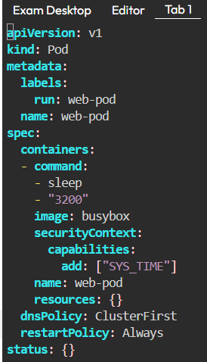
Question No:2 Weightage: 7%
Create a new deployment called myproject, with image nginx:1.16 and 1 replica. Next upgrade the deployment to version 1.17 using rolling update
Make sure that the version upgrade is recorded in the resource annotation.
~$ kubectl create deployment myproject --image=nginx:1.16.
~$ kubectl set image deployment/myproject nginx=nginx:1.17 –record
~$ kubectl rollout history deployment my project

Question No:3 Weightage: 7%
Create a new deployment called my-deployment. Scale
the deployment to 3 replicas. Make sure desired number of pod always running.

~$ kubectl create deployment my-deployment --image=nginx --replicas=3
~$ kubectl get deployment
~$ kubectl get pods
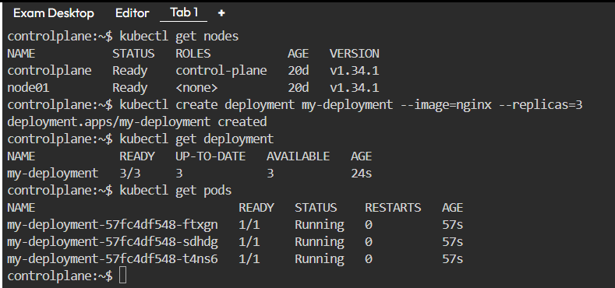
Question No:4 Weightage: 4%
Deploy a web-nginx pod using the nginx:1.17 image with the labels set to tier=web-app.
controlplane:~$ kubectl run web-nginx --image=nginx:1.17 --labels tier=web-app
pod/web-nginx created
controlplane:~$ kubectl get pods
NAME READY STATUS RESTARTS AGE
my-deployment-57fc4df548-ftxgn 1/1 Running 0 10m
my-deployment-57fc4df548-sdhdg 1/1 Running 0 10m
my-deployment-57fc4df548-t4ns6 1/1 Running 0 10m
pod 0/1 CrashLoopBackOff 4 (31s ago) 2m10s
web-nginx 1/1 Running 0 5s
controlplane:~$ kubectl get pods --show-labels
NAME READY STATUS RESTARTS AGE LABELS
my-deployment-57fc4df548-ftxgn 1/1 Running 0 10m app=my-deployment,pod-template-hash=57fc4df548
my-deployment-57fc4df548-sdhdg 1/1 Running 0 10m app=my-deployment,pod-template-hash=57fc4df548
my-deployment-57fc4df548-t4ns6 1/1 Running 0 10m app=my-deployment,pod-template-hash=57fc4df548
web-nginx 1/1 Running 0 9s tier=web-app
controlplane:~$

Question No:5 Weightage: 4%

Create a static pod on node01 called static-pod with image nginx and k gt nyou
have to make sure that it is recreated/restarted automatically in case of any failure happens.

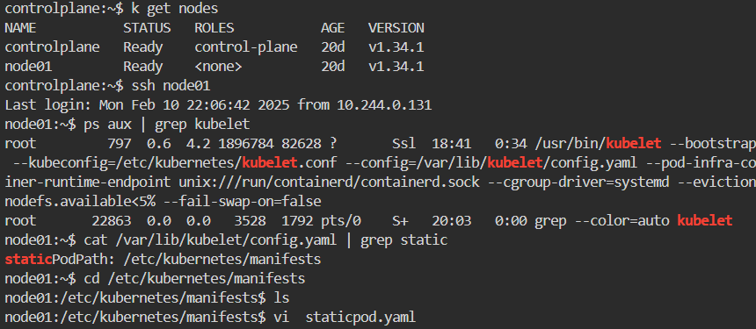
apiVersion: v1
kind: Pod
metadata:
name: static-pod
spec:
containers:
- name: nginx
image: nginx:1.14.2
ports:
- containerPort: 80
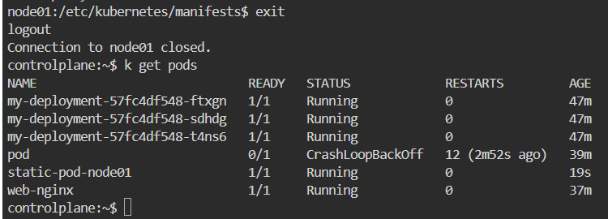
Question No:6 Weightage: 7%
Create a pod called pod-multi with two containers, as given below:
Container 1 - name: container1, image: nginx
Container2 - name: container2, image: busybox, command: sleep 4800
~$ kubectl run pod-multi --image=nginx -o yaml --dry-run=client > pod-multi.yaml
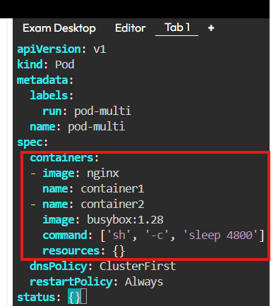

Question No:7 Weightage: 5%
Create a pod called test-pod in "custom" namespace belonging to the test environment (env=test) and backend tier (tier=backend). image: nginx:1.17
~$ k run test-pod --image=nginx:1.17 -n custom --labels env=test --dry-run=client -o yaml > test-pod.yaml
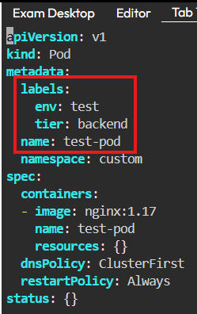
~$ kubectl get pods -A

Question No:8 Weightage: 4%
Get the node node01 in JSON format and store it in a file at ./node-info.json

~$ k get nodes node01 -o json > ./node-info.json

Question No:09 Weightage: 7%
Use JSON PATH query to retrieve the osimages of all the nodes and store it in a file "all-nodes-os-info.txt” at root location.
Note: The osimage are under the nodeInfo section under status of each node.

Ans. Refer from https://kubernetes.io/docs/reference/kubectl/quick-reference/

# Check which nodes are ready
JSONPATH='{range .items[*]}{@.metadata.name}:{range @.status.conditions[*]}{@.type}={@.status};{end}{end}' \
&& kubectl get nodes -o jsonpath="$JSONPATH" | grep "Ready=True"

$ kubectl get nodes -o json

$ kubectl get nodes -o jsonpath='{.items[*].status.nodeInfo.osImage}' > /all-nodes-info.txt
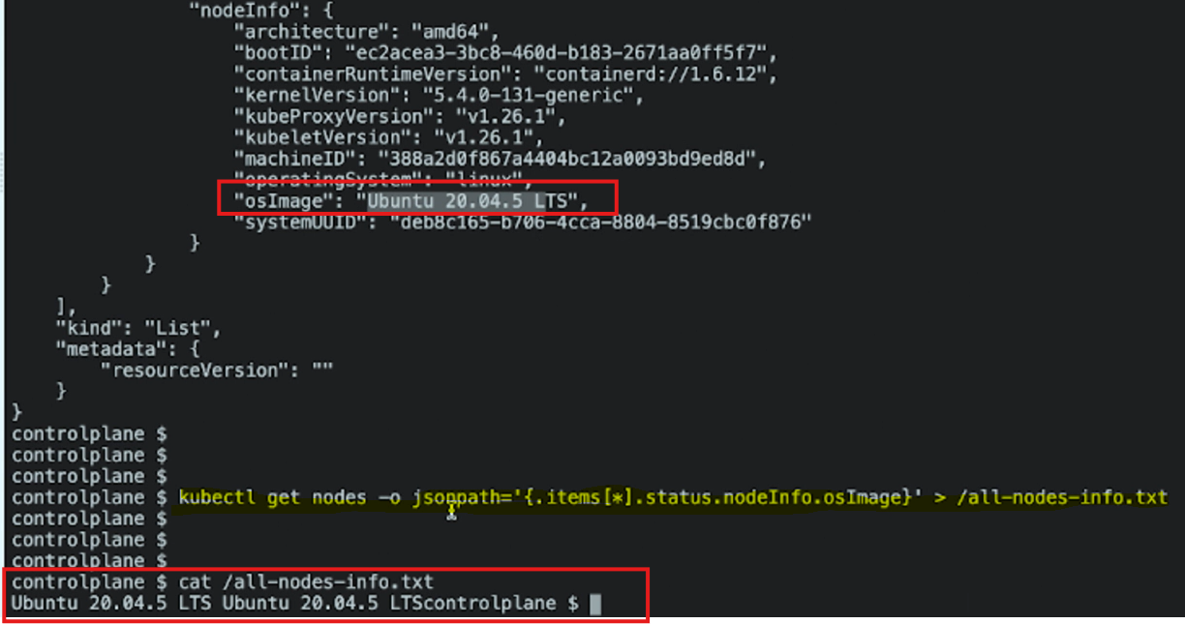

Question No: 10 Weightage: 4%
Create a Persistent Volume with the given specification.
Volume Name: pv-demo Storage:100Mi
Access modes: ReadWriteMany Host Path: /pv/host-data
Ans.
controlplane:~$ vi mypersistentvolume.yaml
controlplane:~$ kubectl apply -f mypersistentvolume.yaml
persistentvolume/pv-demo created
controlplane:~$ k get pv
NAME CAPACITY ACCESS MODES RECLAIM POLICY STATUS CLAIM STORAGECLASS VOLUMEATTRIBUTESCLASS REASON AGE
pv-demo 100Mi RWX Retain Available <unset> 5s
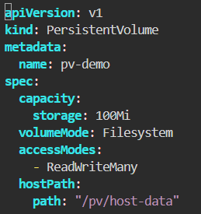
Question No: 11 Weightage: 7%
Worker Node “node01” not responding, Debug the issue and fix it.
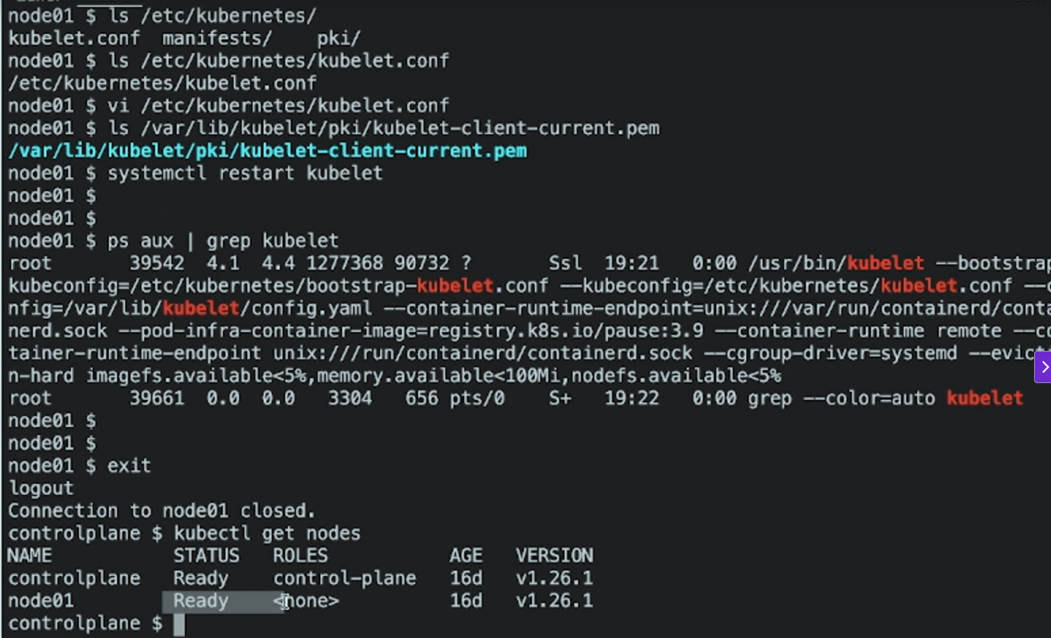

Question No:12 Weightage: 11%
Upgrade the Cluster (Master and worker Node) from 1.18.0 to 1.19.0. Make sure to first drain both Node and make it available after upgrade.
Ans: Search k8s documentation for k8s version upgrade and go for Upgrading kubeadm clusters | Kubernetes
https://v1-33.docs.kubernetes.io/docs/tasks/administer-cluster/kubeadm/kubeadm-upgrade/
- Upgrade kubeadm:# replace x in 1.34.2 with the latest patch version
$ sudo apt-mark unhold kubeadm && \
$ sudo apt-get update && sudo apt-get install -y kubeadm='1.34.2-*' && \
$ sudo apt-mark hold kubeadm
- Verify that the download works and has the expected version:
$ kubeadm version
- Verify the upgrade plan:
$ sudo kubeadm upgrade plan
- Choose a version to upgrade to, and run the appropriate command. For example:
# replace x with the patch version you picked for this upgrade
$ sudo kubeadm upgrade apply v1.34.2
For the other control plane nodes
Same as the first control plane node but use:
$ sudo kubeadm upgrade node
instead of:
$ sudo kubeadm upgrade apply
Also calling kubeadm upgrade plan and upgrading the CNI provider plugin is no longer needed.
Drain the node
Prepare the node for maintenance by marking it unschedulable and evicting the workloads:
# replace <node-to-drain> with the name of your node you are draining
$ kubectl drain <node-to-drain> --ignore-daemonsets
Upgrade kubelet and kubectl
- Upgrade the kubelet and kubectl:
  - Ubuntu, Debian or HypriotOS
  - CentOS, RHEL or Fedora
- # replace x in 1.34.2 with the latest patch version
- sudo apt-mark unhold kubelet kubectl && \
- sudo apt-get update && sudo apt-get install -y kubelet='1.34.2' kubectl='1.34.2' && \
- sudo apt-mark hold kubelet kubectl
- Restart the kubelet:
- sudo systemctl daemon-reload
- sudo systemctl restart kubelet
Uncordon the node
Bring the node back online by marking it schedulable:
# replace <node-to-uncordon> with the name of your node
$ kubectl uncordon <node-to-uncordon>
Q.13 Take a backup of the ETCD database and save it to “/opt/etcd-backup.db”. Also restore the ETCD database from the backup.
controlplane:~$ sudo apt-get update
controlplane:~$ sudo apt-get install etcd-client
controlplane:~$ etcdctl version
controlplane:~$ ETCDCTL_API=3 etcdctl --endpoints=https://127.0.0.1:2379 \
--cacert=/etc/kubernetes/pki/etcd/ca.crt \
--cert=/etc/kubernetes/pki/etcd/server.crt \
--key=/etc/kubernetes/pki/etcd/server.key \
member list
controlplane:~$ ETCDCTL_API=3 etcdctl snapshot save snapshot.db

controlplane:~$ cat /etc/kubernetes/manifests/etcd.yaml | grep file
controlplane:~$ ETCDCTL_API=3 etcdctl --endpoints=https://127.0.0.1:2379 --cacert=/etc/kubernetes/pki/etcd/ca.crt --cert=/etc/kubernetes/pki/etcd/server.crt --key=/etc/kubernetes/pki/etcd/server.key snapshot save /opt/etcd-backup.db

controlplane:~$ ETCDCTL_API=3 etcdctl \
--endpoints=https://127.0.0.1:2379 \
--cacert=<correct-path-to-ca.crt> \
--cert=<correct-path-to-server.crt> \
--key=<correct-path-to-server.key> \
snapshot save /opt/etcd-backup.db
controlplane:~$ ETCDCTL_API=3 etcdctl --data-dir=/var/lib/etcd-backup snapshot restore /opt/etcd-backup.db
Change hostPath in /etc/kubernetes/manifests/etcd.yaml
From /var/lib/etcd To /var/lib/etcd-backup

Q.14 Create a new user “ajeet”. Grant him access to the cluster. User “ajeet” should have permission to create,list,get,update and delete pods. The private key exists at location:
/root/Ajeet/.key and csr at /root/ajeet.csr
https://kubernetes.io/docs/tasks/tls/certificate-issue-client-csr/

Taints & Toleration Example
Add a Toleration to a Pod YAML
Add the Toleration
In the currect directory, you will see a file named pod-tolerate.yaml . Open the file and add a toleration for the taint that's applied to the control plane node.
Control Plane Node has below taint:
Taints: node-role.kubernetes.io/control-plane:NoSchedule
YAML:
apiVersion: v1
kind: Pod
metadata:
creationTimestamp: null
labels:
run: nginx
name: nginx
spec:
containers:
- image: nginx
name: nginx
nodeSelector:
kubernetes.io/hostname: controlplane
tolerations:
- key: "node-role.kubernetes.io/control-plane"
operator: "Exists"
effect: "NoSchedule"

Q.15 Weightage: 4%
Create a nginx pod called dns-resolver using image nginx, expose it internally with a service called dns- resolver-service.
Check if pod and service name are resolvable from within the cluster.
Use the image: busybox: 1.28 for dns lookup.
Save the result in /root/nginx.svc
Ans:
controlplane:~$ kubectl run dns-resolver --image nginx
controlplane:~$ kubectl expose pod dns-resolver --name=dns-resolver-service --port=80 --target-port=80 --type=ClusterIP
controlplane:~$ kubectl run test-nslookup --image=busybox:1.28 --rm -it --restart=Never -- nslookup dns-resolver-service > /root/nginx.svc
Server: 10.96.0.10
Address 1: 10.96.0.10 kube-dns.kube-system.svc.cluster.local

Name: dns-resolver-service
Address 1: 10.106.76.129 dns-resolver-service.default.svc.cluster.local
pod "test-nslookup" deleted from default namespace
controlplane:~$

Question No: 16 Weightage: 7%
A pod "appychip” (image=nginx) in default namespace is not running.
Find the problem and fix it and make it running.
https://kubernetes.io/docs/concepts/scheduling-eviction/taint-and-toleration/
controlplane:~$ k get nodes
NAME STATUS ROLES AGE VERSION
controlplane Ready control-plane 10d v1.34.1
controlplane:~$ k describe node controlplane | grep Taint
Taints: <none>
controlplane:~$ kubectl taint nodes controlplane color=blue:NoSchedule
node/controlplane tainted
controlplane:~$ k describe node controlplane | grep Taint
Taints: color=blue:NoSchedule
controlplane:~$ k run appychip --image=nginx
pod/appychip created
controlplane:~$ k get pod
NAME READY STATUS RESTARTS AGE
apache-7b8c8c4b44-cxb6w 1/1 Running 0 4m23s
appychip 0/1 Pending 0 8s
controlplane:~$ k edit pod appychip
pod/appychip edited
controlplane:~$ k get pod
NAME READY STATUS RESTARTS AGE
apache-7b8c8c4b44-cxb6w 1/1 Running 0 7m50s
appychip 0/1 ContainerCreating 0 3m35s
controlplane:~$ k get pod
NAME READY STATUS RESTARTS AGE
apache-7b8c8c4b44-cxb6w 1/1 Running 0 7m55s
appychip 1/1 Running 0 3m40s
controlplane:~$

Q.17
Question No: 17 Weightage: 5%
Create a ReplicaSet (Name: appychip, Image: nginx:1.18,Replica: 4)
There is already a Pod running in a cluster.
Make sure that the total count of pods running in the cluster is not more than 4
https://kubernetes.io/docs/concepts/workloads/controllers/replicaset/

Question No: 18 Weightage: 11%
Create a Network Policy named "appychip" in default namespace There should be two types, ingress and egress.
The ingress should block traffic from an IP range of your choice except some other IP range. Should also have namespace and pod selector.
Ports for ingress policy should be 6379
For Egress, it should allow traffic to an IP range of your choice on 5978 port.
https://raw.githubusercontent.com/kubernetes/website/main/content/en/examples/service/networking/networkpolicy.yaml
apiVersion: networking.k8s.io/v1
kind: NetworkPolicy
metadata:
name: appychip
namespace: default
spec:
podSelector:
matchLabels:
role: db
policyTypes:
- Ingress
- Egress
ingress:
- from:
- ipBlock:
cidr: 172.17.0.0/16
except:
- 172.17.1.0/24
- namespaceSelector:
matchLabels:
project: myproject
- podSelector:
matchLabels:
role: frontend
ports:
- protocol: TCP
port: 6379
egress:
- to:
- ipBlock:
cidr: 10.0.0.0/24
ports:
- protocol: TCP
port: 5978

Question No:19 Weightage: 7%
You have access to multiple clusters from your main terminal through kubectl contexts. Write all those context names into /opt/course/1/contexts.
Next write a command to display the current context into /opt/course/1/context_default_kubectl.sh, the command should use kubectl .
Finally write a second command doing the same thing into /opt/course/1/context_default_no_kubectl.sh, but without the use of
kubectl .

Question No:20 Weightage: 1%
There are various Pods in all namespaces. Write a command into /opt/course/5/find_pods.sh which lists all Pods sorted by their AGE (metadata.creationTimestamp).
Write a second command into /opt/course/5/find_pods_uid.sh which lists all Pods sorted by field metadata.uid. Use kubectl sorting for both commands
controlplane:~$ k run alfa --image=nginx --restart=Never -n red
pod/alfa created
controlplane:~$ k run beta --image=nginx --restart=Never -n blue
pod/beta created
controlplane:~$ k run gamma --image=nginx --restart=Never -n yellow
pod/gamma created
controlplane:~$ k get pod --all-namespaces
controlplane:~$ kubectl get pod -A --sort-by=.metadata.creationTimestamp
controlplane:~$ kubectl get pod -A --sort-by=.metadata.uid
controlplane:~$ mkdir -p /opt/course/5
controlplane:~$ vi /opt/course/5/find_pod.sh
controlplane:~$ chmod +x /opt/course/5/find_pod.sh
controlplane:~$ ./opt/course/5/find_pod.sh
bash: ./opt/course/5/find_pod.sh: No such file or directory
controlplane:~$ cd /opt/course/5/
controlplane:/opt/course/5$ ls
find_pod.sh
controlplane:/opt/course/5$ ./find_pod.sh
controlplane:/$ vi /opt/course/5/find_pods_uid.sh
controlplane:/$ ./opt/course/5/find_pods_uid.sh
bash: ./opt/course/5/find_pods_uid.sh: Permission denied
controlplane:/$ chmod +x /opt/course/5/find_pods_uid.sh
controlplane:/$ ./opt/course/5/find_pods_uid.sh
Question No: 21 Weightage: 2%
Ssh into the controlplane node with ssh cluster1-controlplane1 . Check how the controlplane components kubelet, kube-apiserver, kubescheduler, kube-controller- manager and etcd are started/installed on the controlplane node. Also find out the name of the DNS application and how it's started/installed on the controlplane node.
Write your findings into file /opt/course/8/controlplane-components.txt. The file should be structured like:
# /opt/course/8/controlplane-components.txt
kubelet: [TYPE]
kube-apiserver: [TYPE]
kube-scheduler: [TYPE]
kube-controller-manager: [TYPE]
etcd: [TYPE]
dns: [TYPE] [NAME]
CERTIFIED kubernetes
APPLICATION DEVELOPER
Choices of [TYPE] are: not-installed, process, static-pod, pod

Ans.
controlplane:~$ find /etc/systemd/system | grep kube
/etc/systemd/system/multi-user.target.wants/kubelet.service
controlplane:~$ find /etc/systemd/system/ | grep etcd
controlplane:~$ find /etc/kubernetes/manifests/
/etc/kubernetes/manifests/
/etc/kubernetes/manifests/kube-scheduler.yaml
/etc/kubernetes/manifests/etcd.yaml
/etc/kubernetes/manifests/kube-apiserver.yaml
/etc/kubernetes/manifests/kube-controller-manager.yaml
controlplane:~$ kubectl -n kube-system get pod -o wide | grep controlplane

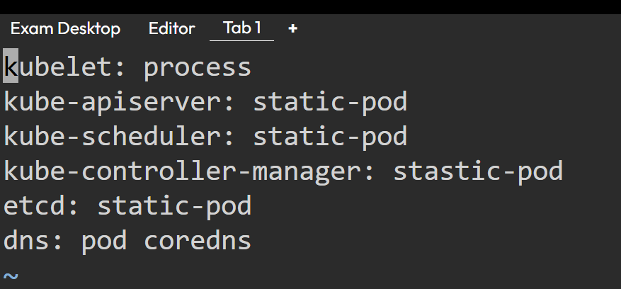
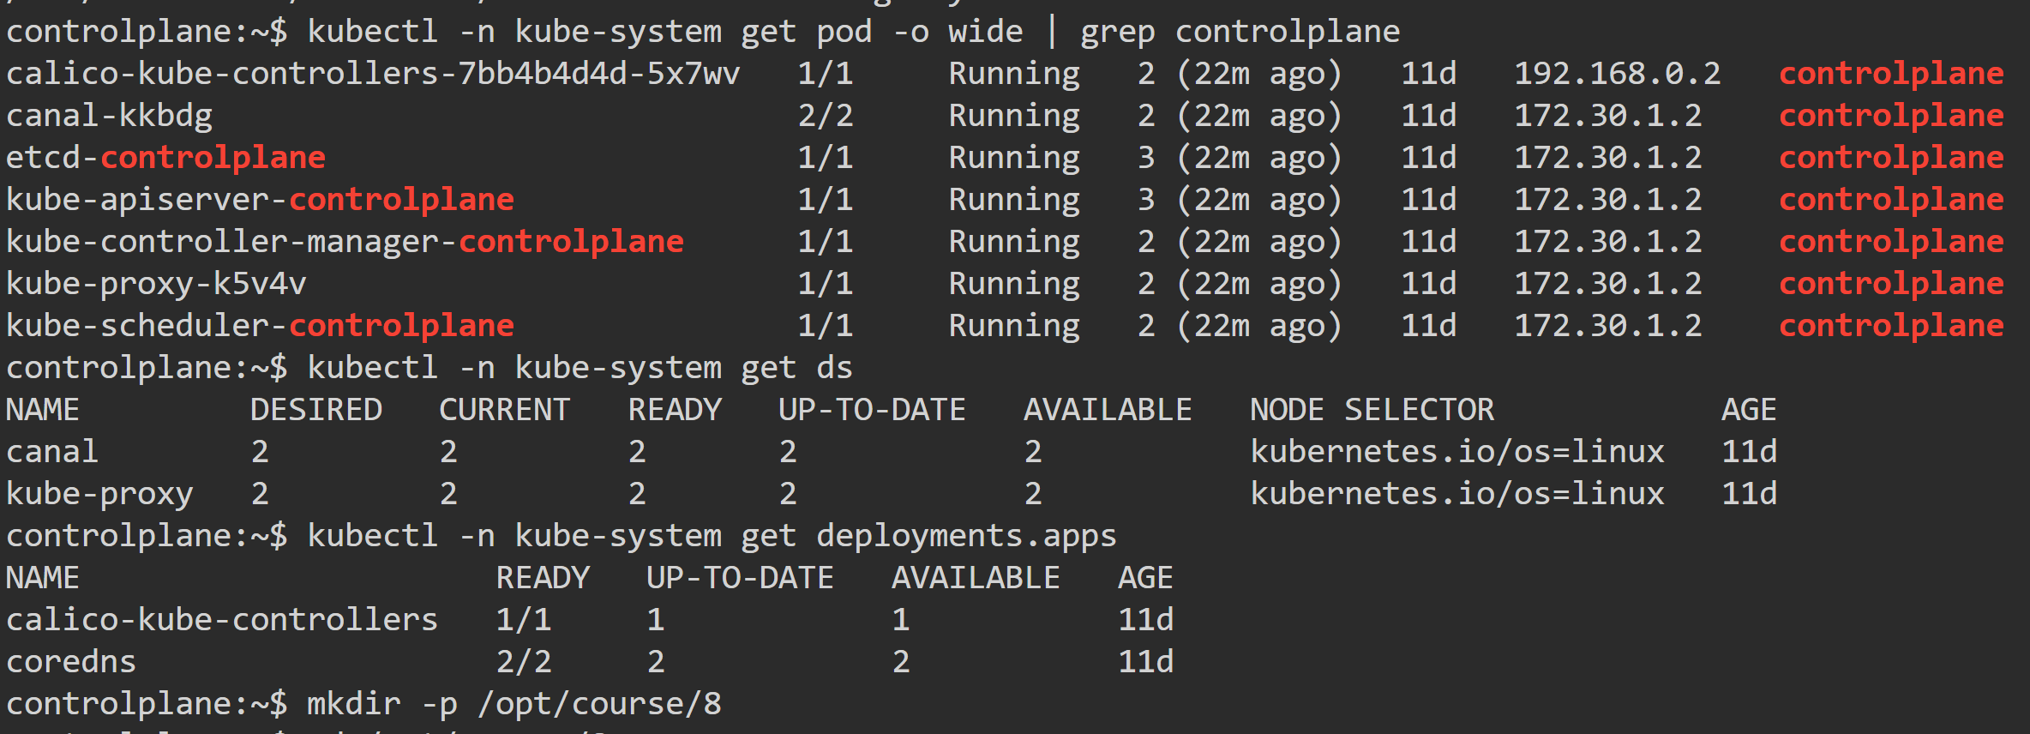

Question No:22 Weightage: 11%
Create a new namespace named appychip.
Create a new network policy named my-policy in the appychip namespace
Requirements
1. Network Policy should allow PODS within the appychip to connect to each other only on port 80. No other ports should be allowed
2. No PODs from outside of the appychip should be able to connect to any pods inside the appychip
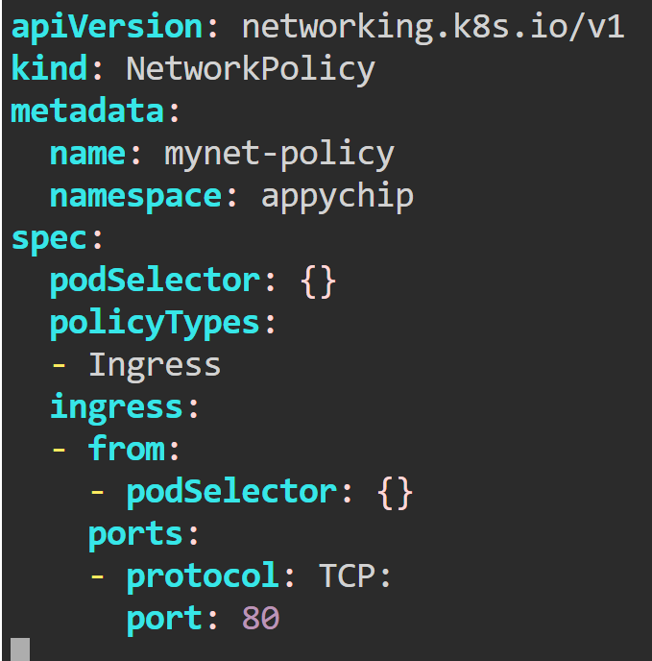

Question No:23 Weightage: 7%
Create a pod output-pod which write "Congratulations! You have passed CKA Exam” into a file “output-pod.txt”
•The Pod output-pod should be deleted automatically after writing the text to the file.

controlplane:~$ k run output-pod --image=busybox -it --rm --restart=Never -- /bin/sh -c 'echo Congratulations ! you have passed the CKA exam' > output-pod
.txt
Question No:23 Weightage: 7%
• Create a pod my-app to run application on port 80
• Expose the my-app pod with a service my-app-service on port 30002 on the nodes in the cluster.
Ans. controlplane:~$ k run my-app --image=nginx --port=80 --labels=app=my-app
controlplane:~$ k expose pod my-app --name=my-app-service --port=80 --target-port=3002 --type=NodePort --dry-run=client -o yaml > m
y-app-service.yaml
controlplane:~$ vi my-app-service.yaml
controlplane:~$ k apply -f my-app-service.yaml
service/my-app-service created
controlplane:~$ k get svc
NAME TYPE CLUSTER-IP EXTERNAL-IP PORT(S) AGE
kubernetes ClusterIP 10.96.0.1 <none> 443/TCP 11d
my-app-service NodePort 10.96.156.124 <none> 80:30722/TCP 15s
controlplane:~$

